Our Beautiful Yarra Park
By Angela Mercer
Coronavirus has not done a lot of good to the world but the gift it has given to the residents of East Melbourne and Richmond is the emergence of Yarra Park as the truly beautiful place it should be. A casual visitor will now see a lovely park, with lush green grass and scarcely a bare patch to be seen, being used as all parks should be used, purely for recreation.
There are families picnicking, children playing ball or just running around for the sheer joy of it, adults exercising either on their own or with a personal trainer or supportive friend. There are many many walkers, some moving briskly and with purpose and others meandering along, often with dogs who cannot believe their luck. Never have the local canines had so many walks in a day, as their working-from-home owners look for an excuse to take a short break.
After these months of sheer pleasure in having Yarra Park to ourselves to enjoy, once restrictions are lifted we will all find it very hard to hand it back to the MCG. Once again it will be used for nearly 200 days each year as a car park, with huge bare muddy patches ploughed up by the thousands of vehicles, with careless drivers and passengers thoughtlessly dropping their litter on the ground and the occasional hoon thinking it great fun to do wheelies in the mud.
The damage to the park is not caused solely by car-parking for sporting events at the MCG or the Tennis Centre. Because of recent Government security measures such as the 80m ‘safe zone’ near the concourse and security bollards everywhere, the number of cars that could be parked has been considerably decreased, resulting in a shortfall in revenue. The MCC therefore thought it had to find other diverse activities to boost its coffers.
There is the annual New Year’s Eve Family fireworks party, which everyone does enjoy. There is Melbourne Football Club’s Family Day, there have been concerts, some of which have exceeded the EPA sound limits by many decibels, various food festivals and the Open Air Cinema.
By far the most egregious of events in the past twelve months was the Spartan City Run last December which occupied the park for over a week. There were the delineation of the course, the bump-in and bump-out of all the course obstacles plus change rooms, food and merchandise stalls, information and registration kiosks and all the other paraphernalia that goes with such a huge event.
The occupation of virtually all the green space was bad enough, but the last straw was the very firm ‘suggestion’ that all residents stay out of the park for the two days of the racing as even the footpaths would be in use by competitors and/or officials. It was most upsetting to find ourselves prevented from using our park because of a commercial event.
However, we have now regained our park, even if sadly only temporarily and we should make full use of it whilst possible. So get out there and enjoy it while you can; and if you haven’t visited for a while because of disappointment in its appearance, go and have a look. You will be amazed and delighted.
June 2020:
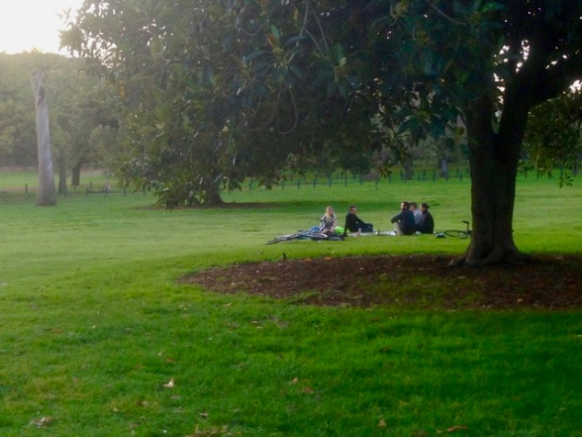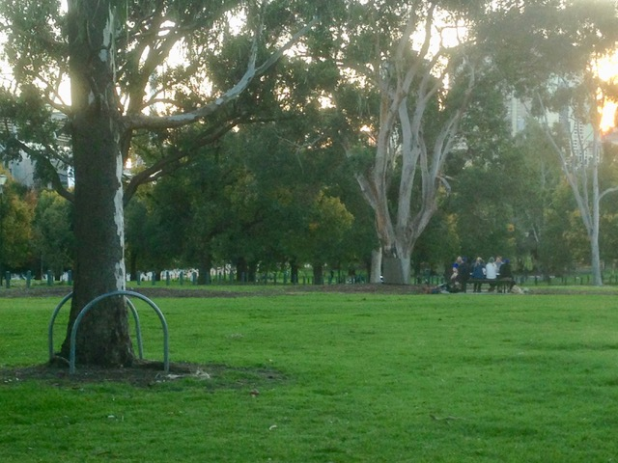

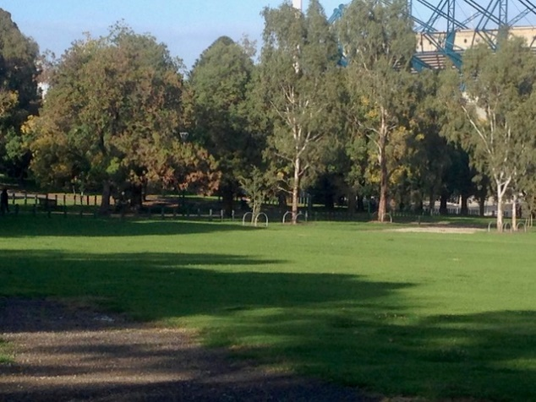

June 2019:
