COVID-19 hit Australia early in 2020 and the impact will be felt for years
by Michele Levine, Gary Morgan & Julian McCrann

In a Roy Morgan survey in mid-March 2020, as restrictions were introduced, 60% of Australian businesses said they’d been affected by COVID-19– up 45% points from the 15% affected in mid-February. In mid-March nearly one-in-five businesses (18%) said they had already been affected ‘A Great Deal’ by COVID-19.
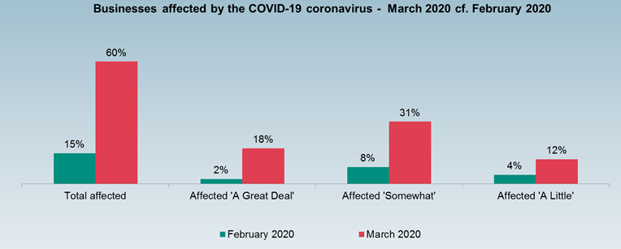
Later that week a majority of 56% of businesses agreed Australia was already ‘in a recession’ including over two-thirds of Queensland businesses (68%) and majorities in NSW (56%) & Victoria (51%).

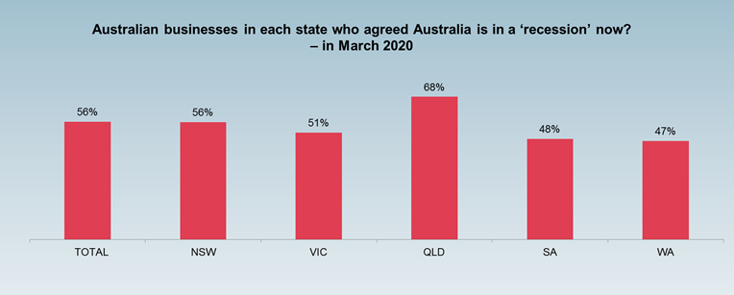

ANZ-Roy Morgan Consumer Confidence tracked the impact of the shut-downs on consumers throughout the pandemic

ANZ-Roy Morgan Consumer Confidence peaked at 109.1 on February 15/16, 2020. As fears about COVID-19 increased Consumer Confidence dropped gradually to the neutral level of 100.0 on March 14/15. That weekend saw the cancellation of the Formula 1 Grand Prix and introduction of the first restrictions on ‘crowd sizes’ and resulted in a record plunge in Consumer Confidence the very next weekend – down 27.8% to only 72.2 on March 21/22, 2020.

Further restrictions were announced on March 29 by the newly convened National Cabinet limiting gatherings to a maximum of two people not living together. That weekend also marked the record low point of ANZ-Roy Morgan Consumer Confidence in the nearly fifty year history of the index with ANZ-Roy Morgan Consumer Confidence falling a further 6.9pts (-9.6%) to 65.3.

The last weekend of March marked a turning point. New cases of COVID-19 peaked, Consumer Confidence bottomed and on Monday the Federal Government announced the JobKeeper wage subsidy of $1,500 per fortnight. Consumer Confidence subsequently increased for nine weeks straight over the next two months until May 30/31, 2020.

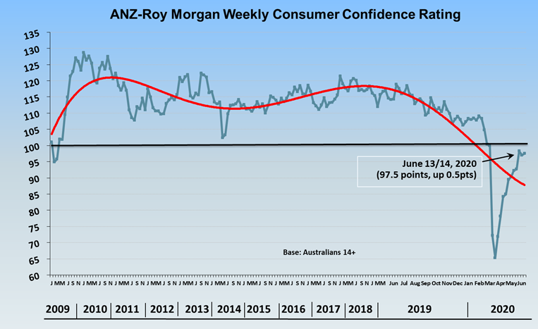

Roy Morgan unemployment spikes by 1.4 million in late March as restrictions close down large parts of the Australian economy

Roy Morgan’s March unemployment figures showed the huge impact of the COVID-19 restrictions with 1.4 million Australians forced out of a job in the second-half of March and a record high 3.92 million (27.4% of the workforce) either unemployed or under-employed. The unprecedented jump in unemployment meant 2.4 million Australians (16.8% of the workforce) were unemployed and 1.5 million Australians (10.6%) were under-employed.

Since the peak in late-March unemployment has subsequently fallen during both April and May. Roy Morgan unemployment and under-employment in May was at 3.459 million (24.5% of the workforce). If this trend of a reduction in total unemployment and under-employment of 25,000 per month were to continue it will take well over four years until September 2024 for the Australian labour market to return to the level it was at in early March 2020 prior to the impact of COVID-19.

Improvement in Roy Morgan Business Confidence lags recovery in ANZ-Roy Morgan Consumer Confidence

For the Australian labour market to return to its pre-pandemic levels it is vital businesses regain the confidence they had during 2019 when Business Confidence averaged 109.0. In March the index dropped to a record low of 95.1 and fell further in April, hitting a new record low of 76.9. The good news is that Business Confidence has begun its recovery and was up 13pts to 89.9 in May 2020.

The increase in May was led by WA & SA which are both in positive territory. However, other states including NSW, Victoria and Queensland are lagging.

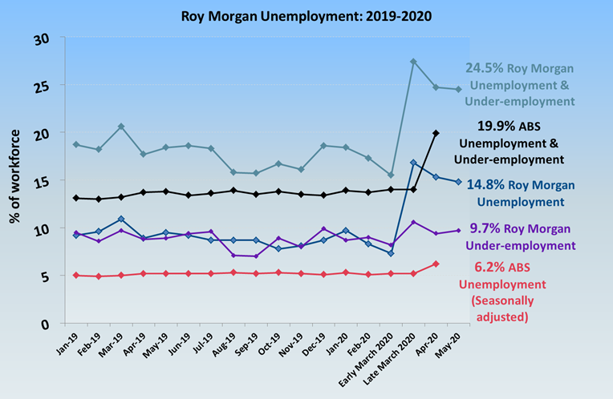

Although Australians are proud of the emergency measures taken by citizens, businesses and governments around Australia, there’s a danger complacency will lead to negative repercussions on the economy later this year when the recovery should be in full swing – Australians can’t rest on their laurels.

