In the lead up to Saturday’s State Election, the East Melbourne Group sent questionnaires to candidates in the Melbourne and Richmond electorates, asking them whether they support Melbourne Football Club’s ill-considered proposal that would see new administration and residential buildings constructed along Wellington Parade, and almost 2 hectares of parkland handed over to the club for an elite training facility. Relevant candidates in the upper house Northern Metropolitan Region were also asked for their views.

The following answers were provided by the candidates.

MELBOURNE CANDIDATES:

Ellen Sandell, Australian Greens

Open space in inner Melbourne is very precious. It should not only be preserved and protected, but extended wherever possible.

We certainly cannot afford to do anything that will take away public parkland.

Open public space is vital for our communities; it keeps us healthy, prepares our urban environment for climate change, and cools our cities.

I have worked hard with the community to protect public open space, from stopping the East-West Link from destroying Royal Park to supporting the community campaign for the former Peter Mac site to stay in public hands, with appropriate height restrictions to prevent overshadowing of the Fitzroy Gardens.

2. Do you support Melbourne Football Club’s proposal to build a new administration centre and training oval within Yarra Park?

No, I do not support Melbourne Football Club’s proposal to build a new administration centre and training oval adjacent to and within Yarra Park.

I love football, but Yarra Park is an important community asset on the Victorian heritage register. Green space in the city is rare, and it should be protected for everyone to use, not carved up for development. Our local heritage must be protected.

According to media reports, concept plans include a six-storey administration centre built over railway tracks near Jolimont Station, and a training oval nearby within Yarra Park.

This would be incredibly detrimental to the community of East Melbourne. The administration centre could significantly impact the heritage of the local area and parkland. Similarly, the construction of an oval would require the removal of trees and soil that would not only reduce the public space available, but also reduce the overall amenity of Yarra Park.

The Government should work with the community and Melbourne Football Club to find a more appropriate space for any necessary new facilities.

- If elected, do you commit to working to oppose the Melbourne Football Club’s proposal?
Yes, I will continue to work with the community to oppose the Melbourne Football Club’s proposal.

I have already been in close contact with the East Melbourne community regarding this proposal. I have met with the East Melbourne Group, and asked questions in Parliament regarding the proposal to gather more information for the community.

The Greens also have a plan to stop parking on Yarra Park. Driving on the parkland damages the roots of important trees and creates dirt tracks. This degradation of the park is unacceptable and must be stopped.

- If elected, do you commit to working to ensure any process around determining the merits or otherwise of the proposal will be independent, public and transparent?
Yes, I will work with the community to hold any government that seeks to go ahead with this proposal to account. Government decisions must be independent, public and transparent, especially when they relate to important community assets such as Yarra Park.

The Labor Government transferred Committee of Management status from the City of Melbourne to the Melbourne Cricket Ground Trust in 2009, to ensure that car parking in Yarra Park would not be reduced. In doing so, they took the management of this public space out of public hands.

Responsibility for the management of Yarra Park should be returned to the City of Melbourne. This would return control of this important public asset to a publicly accountable body and ensure that any changes to the park in future are assessed publicly and transparently, with the best interests of the public as the central concern. It would also allow the Council to directly address the issue of parking in Yarra Park.

Darin Schade, Liberal

- Do you believe that open space in inner Melbourne is precious and should be preserved?

- Do you support Melbourne Football Club’s proposal to build a new administration centre and training oval within Yarra Park?

- If elected, do you commit to working to oppose the Melbourne Football Club’s proposal?

- If elected, do you commit to working to ensure any process around determining the merits or otherwise of the proposal will be independent, public and transparent?

(1-4) I am personally against the destruction of any of our inner city green areas in general, and this ridiculous proposal to co-opt one of our prime inner city public spaces, in particular. I am unaware of any specific Liberal Party policy regarding the issue, however, I commit to fight against any such development and ensure that our parklands and public spaces are protected and enhanced for the use of all of our community, rather than being distributed to commercial ventures. I shall always endeavour to ensure that any such considerations, now or in the future, are conducted in public, with consultation and transparency.

Peter Hanlon

- Do you believe that open space in inner Melbourne is precious and should be preserved?
Unreservedly Yes

- Do you support Melbourne Football Club’s proposal to build a new administration centre and training oval within Yarra Park?
Unreservedly Yes

- If elected, do you commit to working to oppose the Melbourne Football Club’s proposal?
Unreservedly Yes
- If elected, do you commit to working to ensure any process around determining the merits or otherwise of the proposal will be independent, public and transparent?
Unreservedly Yes

Benjamin Rookes, Liberal Democrats

- Do you believe that open space in inner Melbourne is precious and should be preserved?

- Do you support Melbourne Football Club’s proposal to build a new administration centre and training oval within Yarra Park?

- If elected, do you commit to working to oppose the Melbourne Football Club’s proposal?

- If elected, do you commit to working to ensure any process around determining the merits or otherwise of the proposal will be independent, public and transparent?

Kim Fuhrmann, Aussie Battler Party

- Do you believe that open space in inner Melbourne is precious and should be preserved?

- Do you support Melbourne Football Club’s proposal to build a new administration centre and training oval within Yarra Park?

- If elected, do you commit to working to oppose the Melbourne Football Club’s proposal?

- If elected, do you commit to working to ensure any process around determining the merits or otherwise of the proposal will be independent, public and transparent?

Jennifer Kanis, Australian Labor Party
The response to our survey is as below. Following our criticism that this response hid behind process the following letter was circulated by Ms Kanis

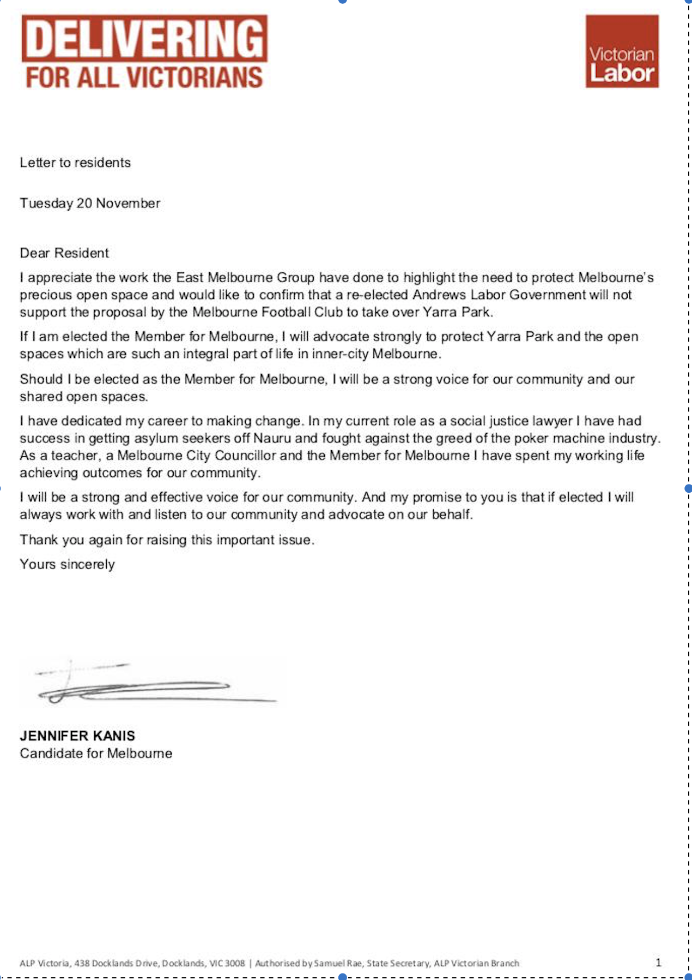
- Do you believe that open space in inner Melbourne is precious and should be preserved?
Yes. The Andrews Labor Government has a strong record of protecting public open spaces in inner Melbourne. Our Government recently announced that if re-elected we will create two new parks in the Richmond electorate. This is part of our $35 million plan to buy or repurpose pockets of land in built-up suburbs to create new parks where there is a lack of public open space. Labor will also invest $10 million for councils to upgrade and landscape underutilised suburban space and local parks.

- Do you support Melbourne Football Club’s proposal to build a new administration centre and training oval within Yarra Park?
The media has reported that this concept is one of several options being considered by the Club. We believe the Club should think some more about the alternatives and come up with an option that has broad community support.

- If elected, do you commit to working to oppose the Melbourne Football Club’s proposal?
Based on the media reporting, if the Club decided to progress the proposal, approval of a planning permit would rest with the City of Melbourne. As Yarra Park is on the Victorian Heritage Register it would also need approval from Heritage Victoria – which is independent of government.
Any proposal would need to address the impacts of a development above the Jolimont rail line and the competing public uses for the area proposed for an oval.

- If elected, do you commit to working to ensure any process around determining the merits or otherwise of the proposal will be independent, public and transparent?
Yes. Major developments impacting on public open space require careful consideration. The use of a Planning Panels Victoria inquiry would seem appropriate for such a major proposal.

Lawrence Pope, Animal Justice Party

- Do you believe that open space in inner Melbourne is precious and should be preserved?

- Do you support Melbourne Football Club’s proposal to build a new administration centre and training oval within Yarra Park?

- If elected, do you commit to working to oppose the Melbourne Football Club’s proposal?

- If elected, do you commit to working to ensure any process around determining the merits or otherwise of the proposal will be independent, public and transparent?

Leo Close, Fiona Patten’s Reason Party

- Do you believe that open space in inner Melbourne is precious and should be preserved?

- Do you support Melbourne Football Club’s proposal to build a new administration centre and training oval within Yarra Park?

- If elected, do you commit to working to oppose the Melbourne Football Club’s proposal?

- If elected, do you commit to working to ensure any process around determining the merits or otherwise of the proposal will be independent, public and transparent?

RICHMOND CANDIDATES:

Herschel Landes

- Do you believe that open space in inner Melbourne is precious and should be preserved?

- Do you support Melbourne Football Club’s proposal to build a new administration centre and training oval within Yarra Park?

- If elected, do you commit to working to oppose the Melbourne Football Club’s proposal?

- If elected, do you commit to working to ensure any process around determining the merits or otherwise of the proposal will be independent, public and transparent?

Emma Manning

- Do you believe that open space in inner Melbourne is precious and should be preserved?

- Do you support Melbourne Football Club’s proposal to build a new administration centre and training oval within Yarra Park?

- If elected, do you commit to working to oppose the Melbourne Football Club’s proposal?
(1-3) I do believe open space and trees in inner Melbourne are precious and should be preserved however I am not aware of the details of this proposal which is outside of my electorate and therefore am not in a position to commit to opposing the proposal at this stage.

- If elected, do you commit to working to ensure any process around determining the merits or otherwise of the proposal will be independent, public and transparent?
If your members are concerned about transparency I am certainly able to commit to working to ensure any planning process includes consultation.

Kathleen Maltzahn, Australian Greens

- Do you believe that open space in inner Melbourne is precious and should be preserved?
Yes, I do. Open space in inner Melbourne is precious, and in short supply - it should not only be preserved and protected, but extended wherever possible. As the inner city becomes home to more people, open space becomes even more important.

- Do you support Melbourne Football Club’s proposal to build a new administration centre and training oval within Yarra Park?
No, I do not support Melbourne Football Club’s proposal to build a new administration centre and training oval adjacent to and within Yarra Park.

Yarra Park is an vital community asset and an important and recognised part of our urban heritage. People who live in the Yarra Park section of Richmond have very very little green space, and for many, Yarra Park is - or should be - their front yard. It is bad enough that Yarra Park is taken over for car parking - it should not be further carved up for development.
According to media reports, concept plans include a six-storey administration centre built over railway tracks near Jolimont Station, and a training oval nearby within Yarra Park.

This would be detrimental to the community and to the park itself. The administration centre could significantly impact the heritage of the local area and parkland. Similarly, the construction of an oval would require the removal of trees and soil that would not only reduce the public space available, but also reduce the overall amenity of Yarra Park.

The Government should work with the community and Melbourne Football Club to find a more appropriate space for any necessary new facilities.

- If elected, do you commit to working to oppose the Melbourne Football Club’s proposal?
Yes, I will work with the community to oppose the Melbourne Football Club’s proposal.

The Greens also have a plan to stop parking on Yarra Park. Driving on the parkland damages the roots of important trees and creates dirt tracks. This degradation of the park is unacceptable and must be stopped.

- If elected, do you commit to working to ensure any process around determining the merits or otherwise of the proposal will be independent, public and transparent?
Yes, I will work with the community to hold any government that seeks to go ahead with this proposal to account. Government decisions must be independent, public and transparent, especially when they relate to important community assets such as Yarra Park.

The Labor Government transferred Committee of Management status from the City of Melbourne to the Melbourne Cricket Ground Trust in 2009, to ensure that car parking in Yarra Park would not be reduced. In doing so, they took the management of this public space out of public hands.

Responsibility for the management of Yarra Park should be returned to the City of Melbourne. This would return control of this important public asset to a publicly accountable body and ensure that any changes to the park in future are assessed publicly and transparently, with the best interests of the public as the central concern. It would also allow the Council to directly address the issue of parking in Yarra Park.

Adrian Whitehead

- Do you believe that open space in inner Melbourne is precious and should be preserved?

- Do you support Melbourne Football Club’s proposal to build a new administration centre and training oval within Yarra Park?

- If elected, do you commit to working to oppose the Melbourne Football Club’s proposal?

- If elected, do you commit to working to ensure any process around determining the merits or otherwise of the proposal will be independent, public and transparent?

Craig Kealy, Animal Justice Party

- Do you believe that open space in inner Melbourne is precious and should be preserved?
Indeed park space in Richmond is at a premium. Yarra Park is regularly used by residents of Richmond to walk their dogs and is the home to many possums (which are protected in Victoria) and birds. This is in addition to humans using the park for their own fitness and leisure purposes. Given the extremely limited park space in the local area, open space is not just precious, but is also the existing home to certain animals.

- Do you support Melbourne Football Club’s proposal to build a new administration centre and training oval within Yarra Park?
Given the intention of the development is to remove 17 mature trees that are home to possums and birds and would significantly reduce the area for owners to walk their dogs, Animal Justice Party would not support the proposal.

- If elected, do you commit to working to oppose the Melbourne Football Club’s proposal?
Animal Justice Party is open to working with both sides of politics, but our key constituents are the animals and we would be working to ensure that animals are not disadvantaged as a result of any such development.

- If elected, do you commit to working to ensure any process around determining the merits or otherwise of the proposal will be independent, public and transparent?
It would be the intention of Animal Justice Party to be transparent throughout the workings of such a proposal.

Kevin Quoc Tran

- Do you believe that open space in inner Melbourne is precious and should be preserved?

- Do you support Melbourne Football Club’s proposal to build a new administration centre and training oval within Yarra Park?

- If elected, do you commit to working to oppose the Melbourne Football Club’s proposal?

- If elected, do you commit to working to ensure any process around determining the merits or otherwise of the proposal will be independent, public and transparent?

Judy Ryan, Fiona Patten’s Reason Party

- Do you believe that open space in inner Melbourne is precious and should be preserved?

- Do you support Melbourne Football Club’s proposal to build a new administration centre and training oval within Yarra Park?

- If elected, do you commit to working to oppose the Melbourne Football Club’s proposal?

- If elected, do you commit to working to ensure any process around determining the merits or otherwise of the proposal will be independent, public and transparent?

Richard Wynne, Australian Labor Party
The response to our survey is as below. Following our criticism that this response hid behind process a letter was circulated by Mr Wynne in the same terms as that from Ms Kanis copied above.

- Do you believe that open space in inner Melbourne is precious and should be preserved?
Yes. The Andrews Labor Government has a strong record of protecting public open spaces in inner Melbourne. Our Government recently announced that if re-elected we will create two new parks in the Richmond electorate. This is part of our $35 million plan to buy or repurpose pockets of land in built-up suburbs to create new parks where there is a lack of public open space. Labor will also invest $10 million for councils to upgrade and landscape underutilised suburban space and local parks.

- Do you support Melbourne Football Club’s proposal to build a new administration centre and training oval within Yarra Park?
The media has reported that this concept is one of several options being considered by the Club. We believe the Club should think some more about the alternatives and come up with an option that has broad community support.

- If elected, do you commit to working to oppose the Melbourne Football Club’s proposal?
Based on the media reporting, if the Club decided to progress the proposal, approval of a planning permit would rest with the City of Melbourne. As Yarra Park is on the Victorian Heritage Register it would also need approval from Heritage Victoria – which is independent of government.
Any proposal would need to address the impacts of a development above the Jolimont rail line and the competing public uses for the area proposed for an oval.

- If elected, do you commit to working to ensure any process around determining the merits or otherwise of the proposal will be independent, public and transparent?
Yes. Major developments impacting on public open space require careful consideration. The use of a Planning Panels Victoria inquiry would seem appropriate for such a major proposal.

NORTHERN METROPOLITAN REGION:

Stephen Jolly, Victorian Socialists

- Do you believe that open space in inner Melbourne is precious and should be preserved?
Yes. As the population explodes we need to protect and indeed expand open space. Parks are the cities lungs. My record as 14 year Yarra Councillor as being the No.1 friend of park expansion and protection in my area eg stopping development on Edinburgh Gardens and many more examples.

- Do you support Melbourne Football Club’s proposal to build a new administration centre and training oval within Yarra Park?
No, it’s an outrage. The real question is how this proposal got this far at all. The answer is weak planning schemes biased towards developers, compliant planning officers and cowardly politicians.

- If elected, do you commit to working to oppose the Melbourne Football Club’s proposal?
Working with locals to exploit every limited opportunity in the planning process to object to this proposal. To lobbying Cllrs to oppose it and, if necessary, to get the Planning Minister to call it in and block it. If all else fails, I’ll do what we did in the 1990s at Albert Park and help organise protests and pickets to stop the building proceeding.

- If elected, do you commit to working to ensure any process around determining the merits or otherwise of the proposal will be independent, public and transparent?
Yes.

Request also sent to candidates of the following parties:
Vote 1 Local Jobs
ALP
Animal Justice
Aussie Battler Party
Derryn Hinch’s Justice
Greens
Health Australia
Liberal Democrats
Liberals
Reason Party
Sustainable Australia

